**Lucrarea de laborator nr.6.**

Studierea etajelor amplificatoare cu tranzistoare

**Sarcina:** De asamblat în softul Multisim circuitele și de efectuat lucrarea de laborator nr.6 conform îndrumarului de la punctul 5.

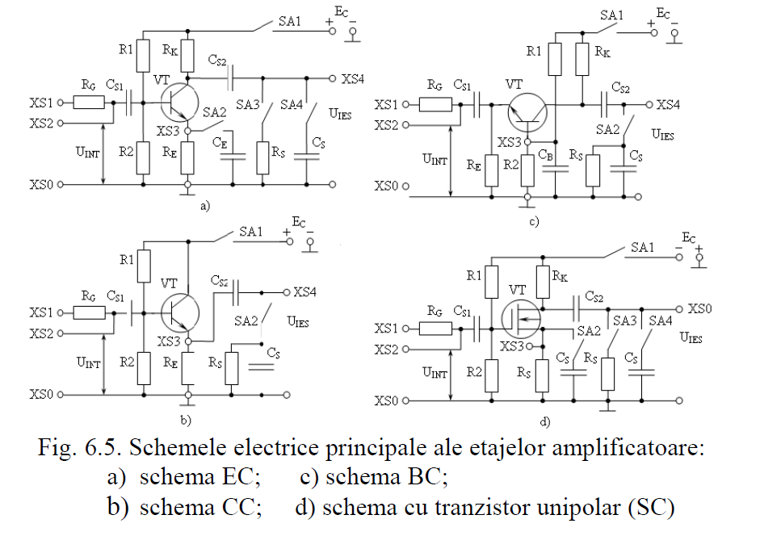

1. Schema EC

CS1=CS2=680 nF

CE=22 µF

R1=0.3 MΩ

R2=50 kΩ

RK=2 kΩ

RE=0.4 kΩ

RS=5.1 kΩ

RG=1 kΩ

EC=15V

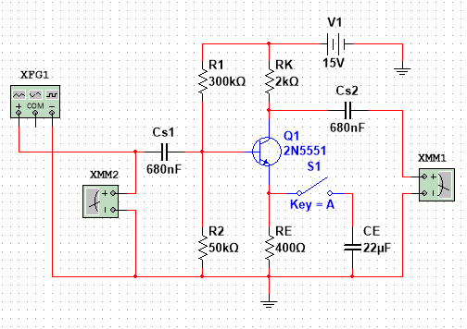

Tabelul pentru ridicarea caracteristicii de transfer a amplificatorului EC fără reacţie.

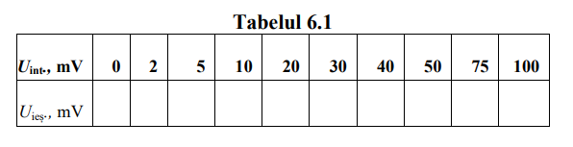

Tabelul pentru ridicarea caracteristicii de transfer a amplificatorului EC cu reacție negativă.

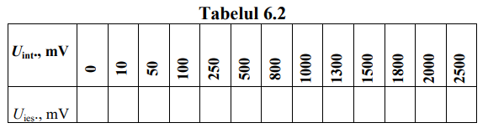

1. Schema CC

CS1=470 nF

CS2=6.8 µF

R1=99.2 kΩ

R2=50.3 kΩ

RE=3.5 kΩ

RG=30.2 kΩ

EC=15V

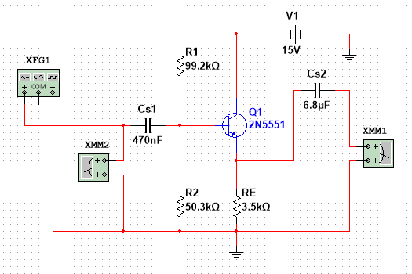

1. Schema BC

CS1=470 nF

CS2=1.6 nF

CB=56 nF

R1=0.275 MΩ

R2=49 kΩ

RK=2 kΩ

RE=0.3 kΩ

RS=0.33 kΩ

RG=0.24 kΩ

Tranzistor 2N5551

EC=15V

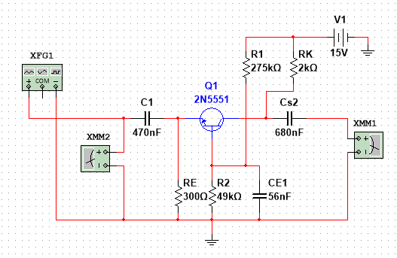

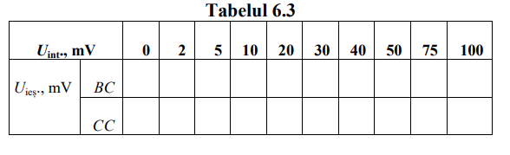

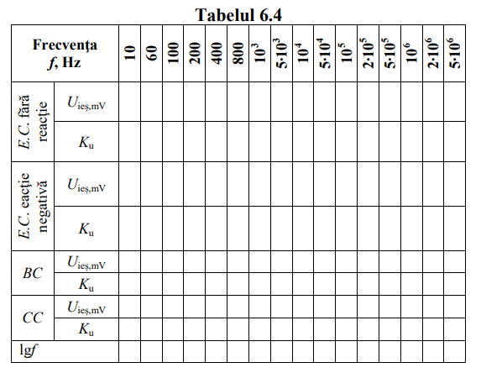

Â

6.1

|  |  |  |  |  |  |  |  |  |  |  |
| --- | --- | --- | --- | --- | --- | --- | --- | --- | --- | --- |
| Uint, mV | **0** | **2** | **5** | **10** | **20** | **30** | **40** | **50** | **75** | **100** |
| Uies, mV |  |  |  |  |  |  |  |  |  |  |

6.2

|  |  |  |  |  |  |  |  |  |  |  |  |  |  |
| --- | --- | --- | --- | --- | --- | --- | --- | --- | --- | --- | --- | --- | --- |
| Uint, mV | **0** | **10** | **50** | **100** | **250** | **500** | **800** | **1000** | **1300** | **1500** | **1800** | **2000** | **2500** |
| Uies, mV |  |  |  |  |  |  |  |  |  |  |  |  |  |

6.3

|  |  |  |  |  |  |  |  |  |  |  |  |
| --- | --- | --- | --- | --- | --- | --- | --- | --- | --- | --- | --- |
| Uint, mV | | **0** | **2** | **5** | **10** | **20** | **30** | **40** | **50** | **75** | **100** |
| Uies mV | BC |  |  |  |  |  |  |  |  |  |  |
| EC |  |  |  |  |  |  |  |  |  |  |

6.4

16

|  |  |  |  |  |  |  |  |  |  |  |  |  |  |  |  |  |  |
| --- | --- | --- | --- | --- | --- | --- | --- | --- | --- | --- | --- | --- | --- | --- | --- | --- | --- |
| **Frecvenţa**  ***f*, Hz** | | **10** | **60** | **100** | **200** | **400** | **800** | **103** | **5∙103** | **104** | **5∙104** | **105** | **2∙105** | **5∙105** | **106** | **2∙106** | **5∙106** |
| *E.C*. fără reacţie | *U*ieș,mV | 35.422 | 134.887 | 218.356 | 418.467 | 743.88 | 1098 | 1185 | 1396 | 1405 | 1408 | 1408 | 1408 | 1408 | 1406 | 1400 | 1363 |
| *K*u | 3.542 | 13.4887 | 21.8356 | 41.8467 | 74.388 | 109.8 | 118.5 | 139.6 | 140.5 | 140.8 | 140.8 | 140.8 | 140.8 | 140.6 | 140 | 136.3 |
| *E.C*. eacţie negativă | *U*ieș,mV | 34.731 | 47.38 | 47.758 | 47.92 | 47.961 | 47.971 | 47.972 | 47.974 | 47.974 | 47.974 | 47.974 | 47.974 | 47.97 | 47.956 | 47.902 | 47.526 |
| *K*u | 3.4731 | 4.738 | 4.7758 | 4.792 | 4.7961 | 4.7971 | 4.7972 | 4.7974 | 4.7974 | 4.7974 | 4.7974 | 4.7974 | 4.797 | 4.7956 | 4.7902 | 4.7526 |
| *BC* | *U*ieș,mV | 6.738 | 9.775 | 9.876 | 9.919 | 9.93 | 9.933 | 9.933 | 9.933 | 9.934 | 9.934 | 9.934 | 9.934 | 9.934 | 9.934 | 9.934 | 9.934 |
| *K*u | 0.738 | 0.9775 | 0.9876 | 0.9919 | 0.993 | 0.9933 | 0.9933 | 0.9933 | 0.9934 | 0.9934 | 0.9934 | 0.9934 | 0.9934 | 0.9934 | 0.9934 | 0.9934 |
| *CC* | *U*ieș,mV | 0.292 | 2.092 | 4.032 | 9.591 | 20.781 | 42.593 | 53.399 | 265.649 | 514.825 | 1482 | 1684 | 1748 | 1767 | 1768 | 1760 | 1700 |
| *K*u | 0.0292 | 0.2092 | 0.4032 | 0.9591 | 2.0781 | 4.2593 | 5.3399 | 26.5649 | 51.4825 | 148.2 | 168.4 | 174.8 | 176.7 | 176.8 | 176 | 170 |
| lg*f* | | 3.321 | 5.906 | 6.643 | 7.643 | 8.643 | 9.643 | 9.965 | 12.287 | 13.287 | 15.609 | 16.609 | 17.609 | 18.931 | 19.931 | 20.931 | 22.253 |

